**Project Proposal**

**Landscape classification**

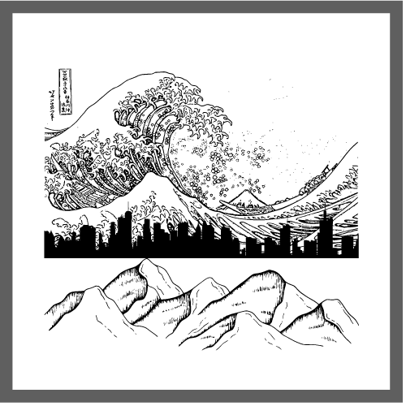

**Name:** Hristo Hristov

**Email:** [h.hristov-ab@student.fontys.nl](mailto:h.hristov-ab@student.fontys.nl)

**Student Number:** 4170431

**Teachers:**

Zhao Qin – [q.zhao@fontys.nl](mailto:q.zhao@fontys.nl)

Hans Konings – [h.konings@fontys.nl](mailto:h.konings@fontys.nl)

John Litsenburg – [j.litsenburg@fontys.nl](mailto:j.litsenburg@fontys.nl)

**Fontys University of Applied Sciences**

**Eindhoven – Netherlands**

**2022**

Contents

Introduction 3

Domain Understanding 4

1. Who is this A.I. designed for? 4

2. Why make this A.I.? 4

3. Benefits that this project will bring to the people using it 5

4. Possible negatives that might come from this A.I. 5

Data Sourcing 6

1. Data sourcing 6

2. Data cleaning methods 6

3. Difficulties in data cleaning 7

Analytical approach 8

1. Type of model that will be used 8

2. Methods that will be applied to the model 9

References 9

# Introduction

The purpose of this document is to present my idea for this semester’s individual challenge. In short, I will be making an A.I. that will take landscape images, analyze them and predict what type of landscape the picture depicts. The document will be split into 3 main parts: **Domain Understanding,** **Data Sourcing,** **Analytical Approach.** In these 3 parts I will answer essential questions of Why, What, Who, When & How.

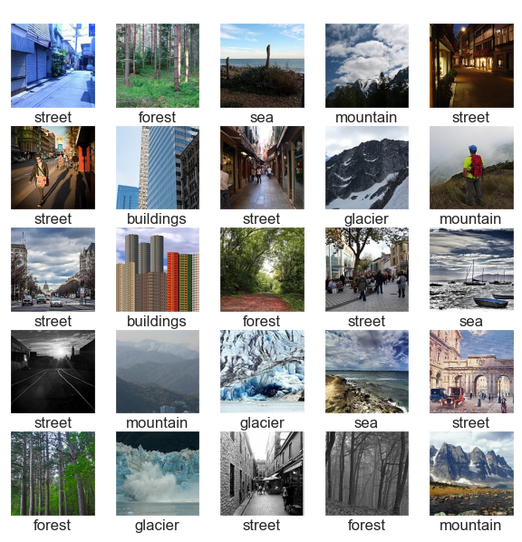

Example of what the A.I. will be able to do.

# Domain Understanding

# Who is this A.I. designed for?

This project is designed mainly towards photography enthusiasts, however every person who has an interest in taking pictures of the world in general can benefit from this project.

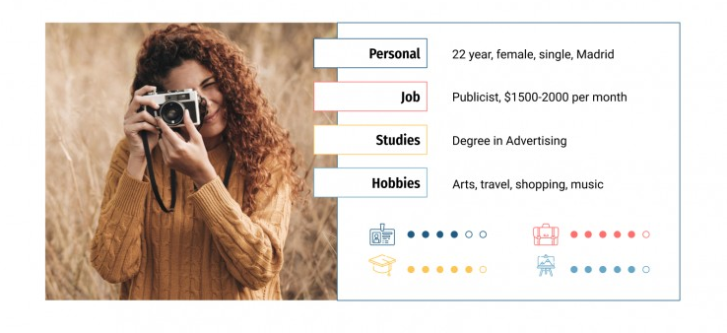

*Persona of what a typical user of this A.I. can look like*

# Why make this A.I.?

With the advancement of technology more and more everyday tasks are becoming automated. Nature photography is now easier than it’s ever been in the past. Traveling is more streamlined and simpler. Natural areas are often more accessible. Not to mention the fact that digital cameras are everywhere. A typical nature photographer can take up to 100-300 photos in one day of taking pictures. Having to manually go through each picture and manually put it a correct folder corresponding to the type of photo it is, is not something that is practical thus no many (if any) people do it. This is the purpose of this A.I. make organization of photography enthusiasts simple and easy to do.

# Benefits that this project will bring to the people using it

As said before there are a 2 main benefits that the people who use this technology will have.

1. Organized photos for easier browsing
2. Saved time that would be used for photos sorting

There’s little that’s quite as dull as sifting through your images and key wording, tagging, starring, folder sorting, and/or color coding them. However every photographer should want to distinguish their files, it helps to find them in a pinch. Instead of spending days organizing years’ worth of pictures the people who make use of this technology can use that time to go and do something they like, for example taking even more pictures of landscapes.

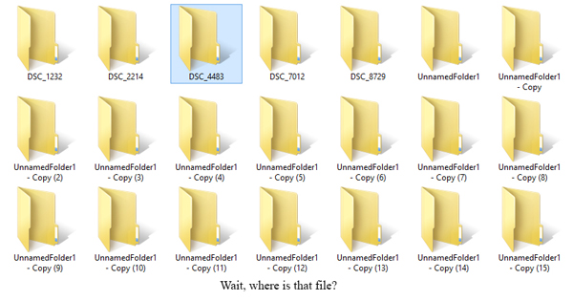

*Example of a messy pictures storage*

# Possible negatives that might come from this A.I.

Although the technology itself does not directly affect the users in a negative way. And the A.I. does not deal with any sensitive information. There are still some ways that this technology can create simple annoyances or even maybe making people lose their jobs. To clarify what I mean, no A.I. is perfect so there are bounds to be mistakes made when categorizing images. Any mislabeling made will have to be manually fixed by the user. When it comes to more serious consequences if this technology becomes widespread, people who organize photos for a living might lose their jobs or at the very least experience a decrease in clients. Photo organizer is a professional who offers extensive photo organization, editing and management services. They work with both printed and digital photos/videos. Should negatives come from this technology they will be most affected.

# Data Sourcing

# Data sourcing

I will be sourcing my data from the data science website Kaggle. The reason being that the data there is already labeled and as such will save me a lot of time and physical labor of me having to manually label the images.

# Data cleaning methods

There are a couple of ways I will go about making sure that the images that I have are clean and ready to be fed into my M.L. model. I will begin by making sure that all of the files that I have in my dataset are indeed images in jpg or png format. After I make sure that all the files are images I will resize them to make sure that there are no pictures with huge dimensions which will take a lot of time to process thus making my algorithm unoptimized, and recoloring them will make sure that they are in the correct color scheme (RGB)



*Example of my detection for files that are not images*

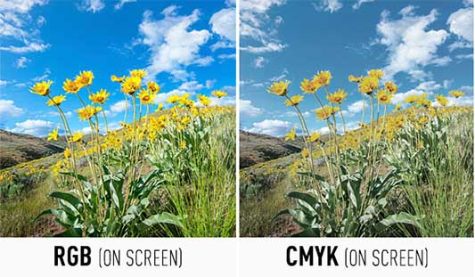

*Example of differences between color schemes in images*

# Difficulties in data cleaning

Since I will be getting all of my data from free sources the image quality that I will have will not be the best possible. This might cause a less accurate A.I. so looking for sources which are both free and can provide me with the quality of data I need will be challenging

# Analytical approach

# Type of model that will be used

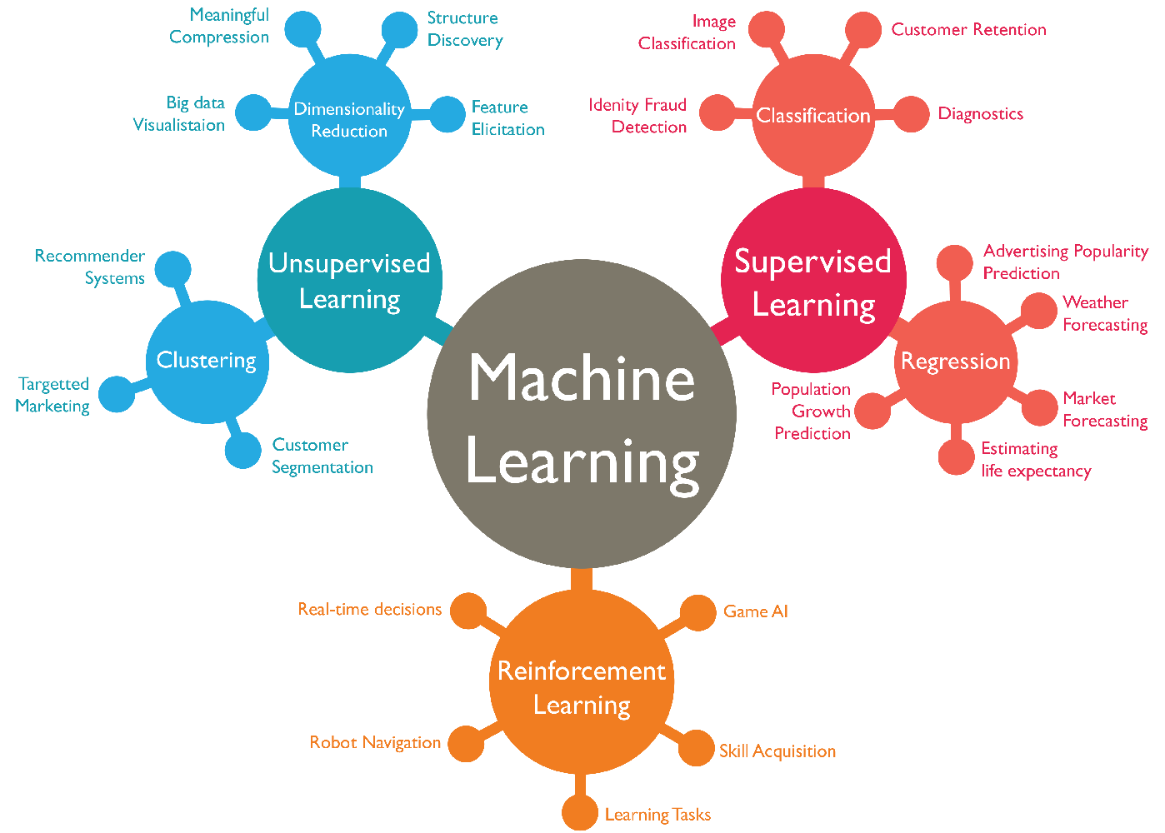

All machine learning models are categorized as supervised, unsupervised or reinforcement learning. Supervised and unsupervised are further broken down into dimensionality reduction/clustering and classification/regression respectively.

I will be training my A.I. using the supervised model of classification as in this project I will be trying to predict to which class (landscape) the picture belongs to.

# Methods that will be applied to the model

Since I will be using Classification, first we must look at the different types of classification. There are two types of Classifications:

* **Binary Classifier:** If the classification problem has only two possible outcomes, then it is called as Binary Classifier.  
  **Examples:** YES or NO, MALE or FEMALE, SPAM or NOT SPAM, CAT or DOG, etc.
* **Multi-class Classifier:** If a classification problem has more than two outcomes, then it is called as Multi-class Classifier.  
  **Example:** Classifications of types of crops, Classification of types of music.

Classification Algorithms can be further divided into the mainly two category:

* **Linear Models**
  + Logistic Regression
  + Support Vector Machines
* **Non-linear Models**
  + K-Nearest Neighbors
  + Kernel SVM
  + Naïve Bayes
  + Decision Tree Classification
  + Random Forest Classification

In my challenge I will be using the Kernel SVM and I will compare it to the CNN model to see which of the 2 has a better accuracy and would be the best fit for my project.

# References

*Dutile, M. (2014, March 20). 8 Reasons You Should Organize Your Photo Collection. Digital Photography School. Retrieved April 28, 2022, from https://digital-photography-school.com/8-reasons-organize-your-photo-collection/*

*Guntur, C. (2021, January 24). 4 Great Ways to Sort Your Photos (It's not as hard as you think!). Organizing Photos. Retrieved April 28, 2022, from https://www.organizingphotos.net/4-great-ways-to-sort-your-photos/*

*Oosterhoff, D. (2016, January 20). The ABCs of Photo Sorting: How to Turn a Mess of Pictures into an Organized Collection. Photo & Video Envato Tuts+. Retrieved April 28, 2022, from https://photography.tutsplus.com/tutorials/the-abcs-of-photo-sorting-how-to-turn-a-mess-of-pictures-into-an-organized-collection--cms-25622*

*Patel, V. (2022, January 5). How many photos do you take at a Nature Photography Location? Visual Wilderness. Retrieved April 28, 2022, from https://visualwilderness.com/fieldwork/how-many-photos-do-i-take-at-a-nature-photography-location*

*Photo Organizers - NAPO Main. (n.d.). Higher Logic, LLC. Retrieved April 28, 2022, from https://point.napo.net/napo-network/specialinterestgroups/photo-organizers#:%7E:text=The%20Photo%20Organizers%20SIG%20is,and%20solutions%20for%20their%20memories.*